|  |  |
| --- | --- |
| **Assignment Case** | Description: LogoBINUS-University |
| WDH1 |
| **Periode Berlaku** Semester Genap 2023/2024  ***Valid on*** *Even Year 2023/2024* | **Software Laboratory Center**  **Assistant Recruitment 24-2** |

## Materi

*Material*

* HTML
* CSS - Inline

## Soal

*Case*

**XeirocK-ya**

XeirocK-ya ramen shop is a cozy haven for noodle lovers, offering a variety of rich, flavorful broths and perfectly cooked noodles. Each bowl is meticulously crafted, with toppings like tender chicken, fresh vegetables, and a soft-boiled egg adding layers of taste and texture. The aroma of simmering broth and the sizzling sound of the prepared ingredients create an inviting atmosphere. XeirocK-ya has opened many branches in various places and needs something that can significantly increase the number of customers coming to XeirocK-ya. So, they devised an idea to make a website so people could know about them. You as the web developer are asked to create this website.

The **requirements** for the **website** are **specified** below:

1. The website contains **three** pages: the **home** page, **menu** page, and **register** **membership** page.
2. Each page must contain a **header**, **navigation bar**, **content**, and **footer**.
3. Ensure that the **styling** of the **website** you **created** must be the **same** as the **XeirocK-ya** **website**.
4. Change the cursor mode to a pointer for every **interactive component** hover (such as buttons, links, etc.).

The **details** of the **website** will be **explained** below.

* **Color Styles**
* Below is the list of **colors** used in this **website** for every element to make the **development** process much **easier**.

|  |  |  |
| --- | --- | --- |
| No | Color | Hex Code |
| 1 | Root Beer | #250303 |
| 2 | Blanched Almond | #FBEECD |
| 3 | Arylide Yellow | #F0CA72 |
| 5 | Chinese Yellow | # FFB000 |

* **Font**
* There is only **one** **font** **typeface** that is used on this **website**. Which is **Poppins**. You can get the font from this [link](https://fonts.google.com/specimen/Poppins).
* **Navigation Bar**
* **The navigation** **bar** will **always** be placed on the **page** and **follows** when **scrolled**.
* **The navigation** **bar** contains a **Xeirock**-**ya** **Logo** header image and **links** to **various** **sections** or **pages**.
* **The navigation bar** will have 2 versions, the first on the home page and the second on the other pages.
* **The home page navigation bar** will have **more** **links** than the **other** **navigation** **bar** can **redirect** the user to an**other** **page** and **scroll** the user to **specific** **sections** on the **home** **page** and the **other page navigation bar** only has links to **redirect** to **another** **page**. You have to create **both** in your **navigation** **bar**.
* Also, **redirect** the user to the **Home** **page** if the **logo** is **clicked**.
* **Make sure** to underline the link text when it is hovered.



Figure 1. Navigation Bar on the home page



Figure 2. The navigation bar on other pages

* Also, consider **changing** the **navigation** **bar style** when **scrolling** like this **image** **below** to increase the user experience.



Figure 3. Navigation Bar when scrolled

* **Footer**
* The footer will always be placed at the end of every page on this website.
* The footer will contain a **XeirocK**-**ya** **logo** **image** with **copyright**, social media links, **internal** links to **various** **home** **page** **sections**, and a **button** to **navigate** users to **other** **pages**.
* When the navigation **button** is **hovered**, give a **hover** **effect** to the **button**.

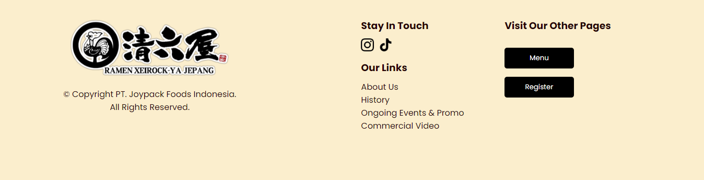

Figure 4. Footer

* **Home Page**
* **The home page** is the first page the user is **redirected** to when **visiting** this **website**.

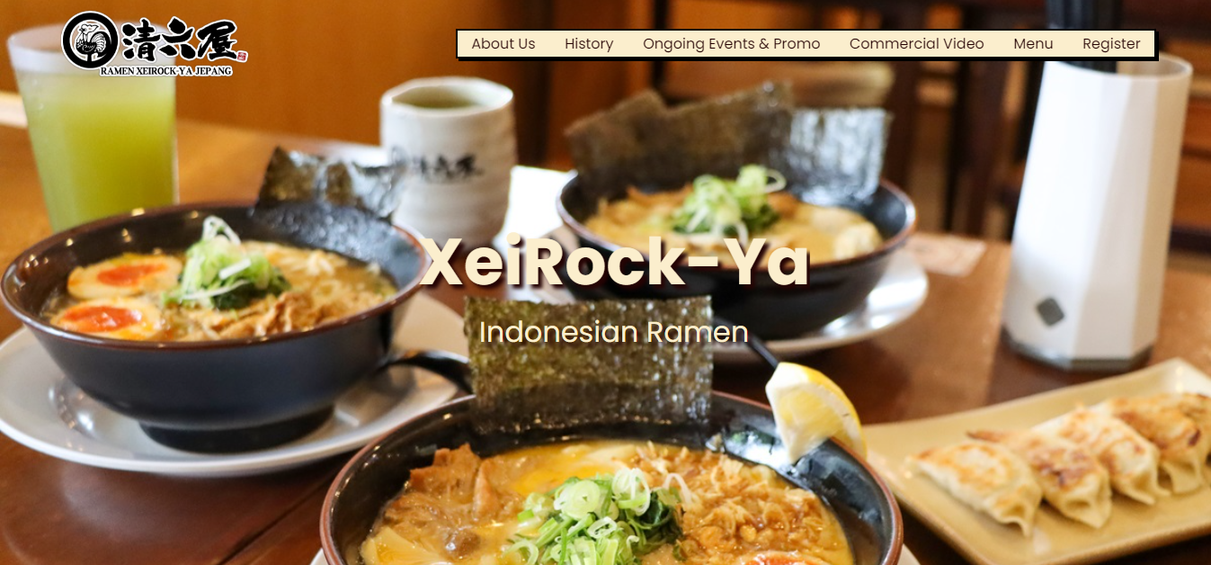

Figure 5. Home page

* **This** page contains **six** **main** **contents**. Which is a **landing** **image**, **about** **us** section, **history** section, **ongoing** **events** & **promos**, **commercial** **video**, and **bottom** **image**.

1. **Landing** **Image**

* This **section** **contains** a **landing** **image** of **Xeirock**-**ya** **ramen**, a **title,** and a **subtitle**. **Consider** the image must be **full**-**screen** and the **title** and **subtitle** at the **center** of the **image**. Also, **ensure** the **image** must be **parallax** or **stay** in **place** **while** the rest **scrolled** **over** it.

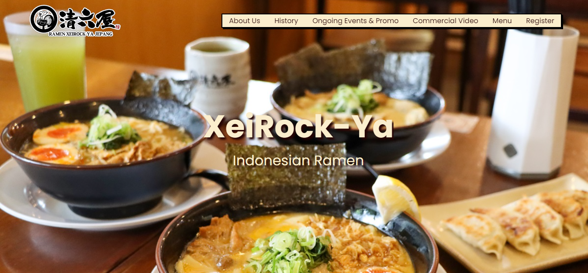

Figure 6. Landing Image

1. **About** **Us** **Section**

* **The About** **Us** section **contains** **general** **information** about **XeirocK**-**ya** **ramen** and **some** **images** about **XeirocK**-**ya** **ramen**.

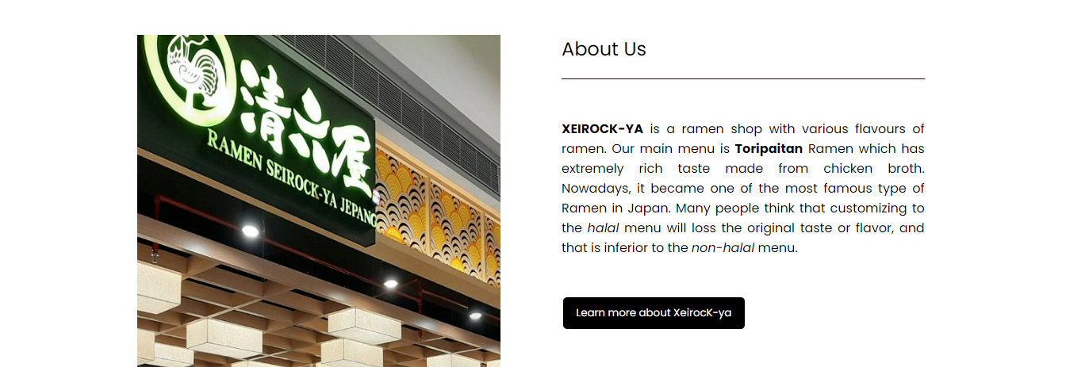

Figure 7. About us section

* This section also **contains** a **learn** **more** **button** that will **change** when **hovered** and **redirect** the user to the **menu** **page** if **clicked**.

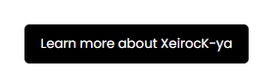

Figure 8. Learn more button

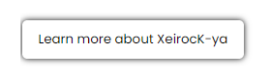

Figure 9. Learn more button (hover)

1. **History** **Section**

* **The history** section contains the **history** of **XeirocK**-**ya** **ramen** **text** with **an** **image** about the **history** of **XeirocK**-**ya**.

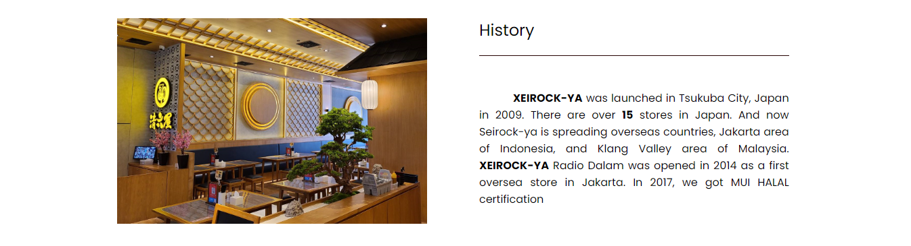

Figure 10. History Section

1. **Ongoing** **Events** **and** **Promos**

* This **section** contains **currently** **ongoing** **events** and **promos** in **XeirocK**-**ya** **Ramen**. There is an **event** **description** **text** with an **image** that describes the **ongoing** **event**. Also, **other** **event images** or **promo** **images** will happen soon.

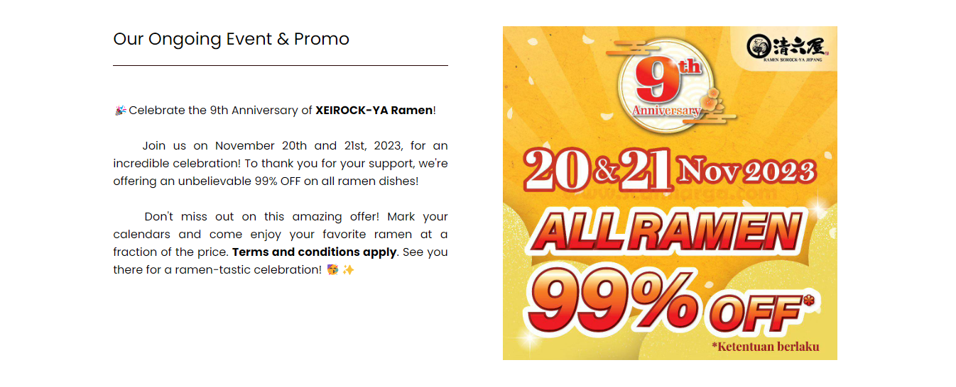

Figure 11. Ongoing Events & Promos Section

* If the other **event** or **promo** **images** are **hovered**, Make the **image** **bigger**.

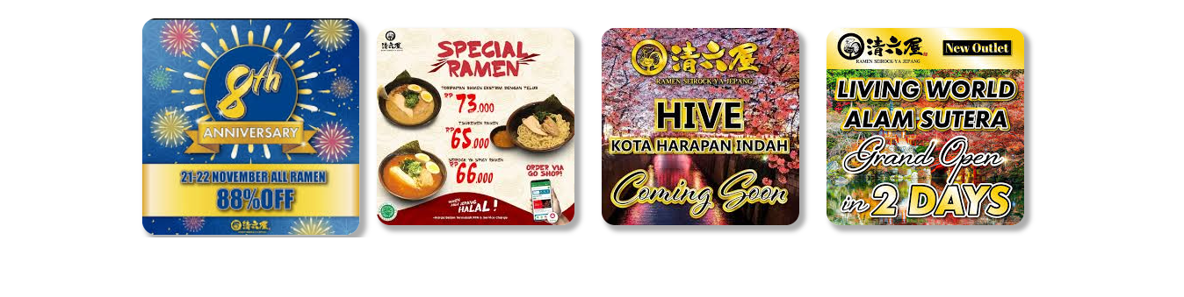

Figure 12. Other event images (hover)

1. **Commercial** **Video**

* Commercial video contains an **iframe** that shows **YouTube** **embedded** **video** from this [link](https://www.youtube.com/watch?v=jK2DvnQQiew&t=7s) **wrapped** with a **border** **image** from the **asset** folder.
* The **iframe** must be **playable**.

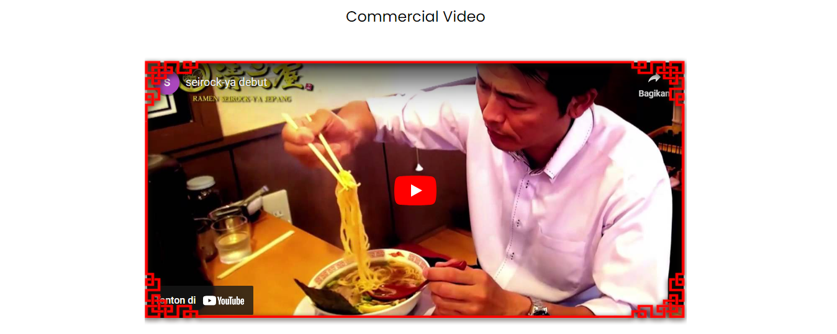

Figure 13. Commercial video section

1. **Bottom** **Image**

* This **section** **contains** a **bottom** **image** of **Xeirock**-**ya** **ramen** that **shows** the **situation** at the **branch** of **XeirocK**-**ya** **ramen** **shop**. Consider the **image** must be a **full**-**width** **screen**. Also, **ensure** the **image** must be **parallax** or **stay** in **place** **while** the rest **scrolled** **over** it.

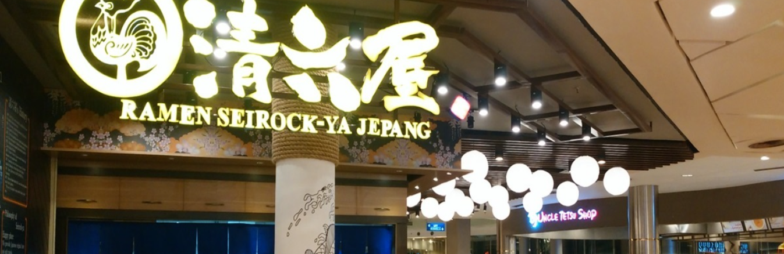

Figure 14. Bottom image

* **Menu Page**
* This **page** contains all **available** **menus** at **XeirocK**-**ya** and has **two** main **contents**. Which is the **menu** **carousel** and **menu** **list**.

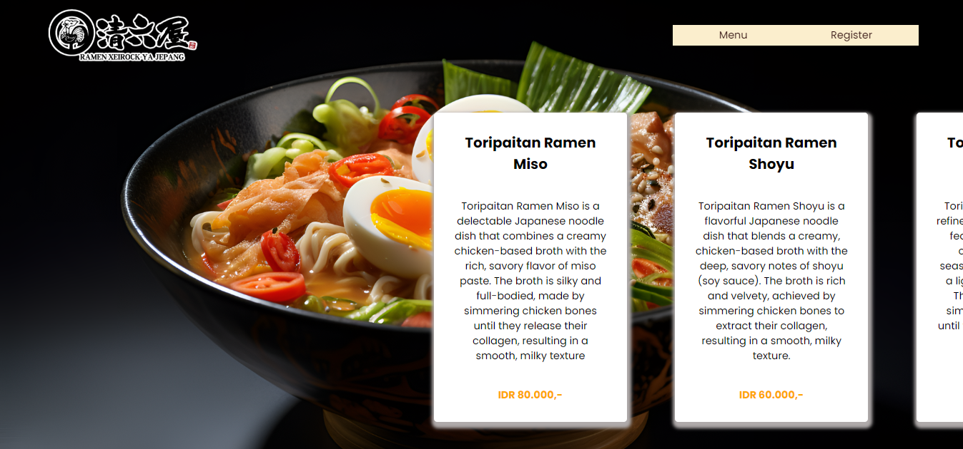

Figure 15. Menu page

1. **Menu** **Carousel**

* The **menu** **carousel** contains a **full**-**screen** **background** **image** and the **ramen** **information** **card**. The ramen information card contains the **name**, **price**, and a **short** **description** of the **ramen**.

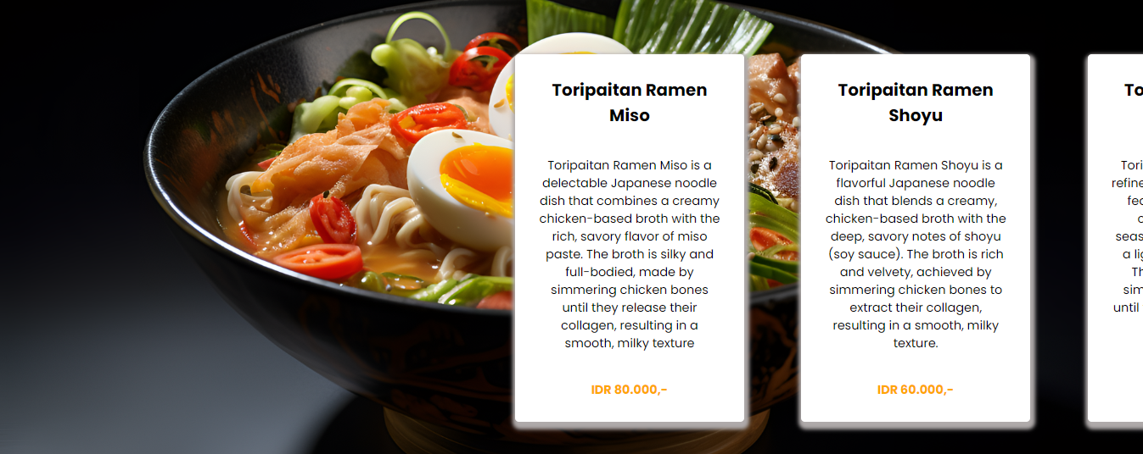

Figure 16. Menu Carousel

* If the **ramen** **information** **card** is **clicked**. It will **change** the **current** **ramen** **image** and **information** **card**.

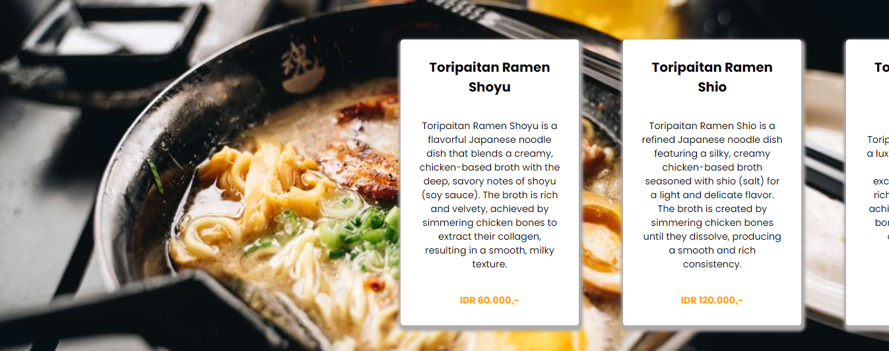

Figure 17. Ramen information card on click

* You can get all **ramen** **images** from the **asset** folder.

1. **Menu** **List**

* The **menu** **list** contains **all** **ramen** **menus** in **XeirocK**-**ya**. Each **menu** contains an **image**, **name**, **price**, and **short** **description**.

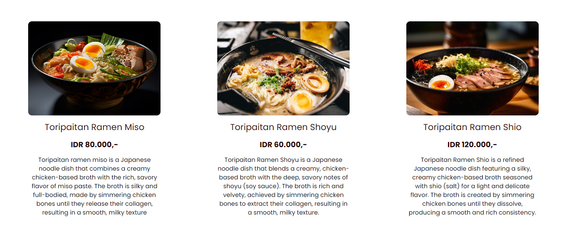

Figure 18. Menu list

* **Register Membership Page**
* This page contains a **background** **image** and a **form** to **register** as XeirocK-ya members. The **form** consists of **two** parts: **personal** **information** and **membership** **details**.
* Each **form** part has an **image** beside the **form** **part**.

1. **Personal** **Information**

* This **part** contains a **title** and **personal** **information** **input** **fields** such as **name**, **email**, **phone** **number**, **DOB**, and **gender**.

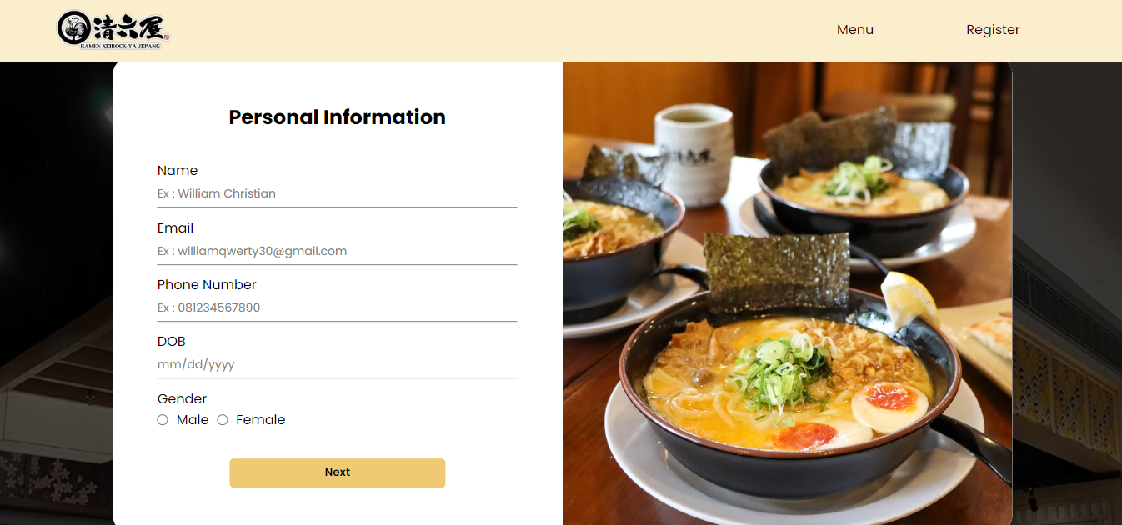

Figure 19. Personal information form

* Each **personal** **information** **input** **field** must have a **different** **input** **type**.
* This part also contains a **next** **button** to **show** the **membership** **detail** part. If the button is **hovered**, change the **style** of the **button**.

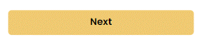

Figure 20. Next button



Figure 21. Next button (hover)

1. **Membership** **Detail**

* This **part** contains a **title** and **membership** **detail** **input** **fields** such as **membership** **type**, **membership** **duration**, **reason** to be **membership** and **agreement**.

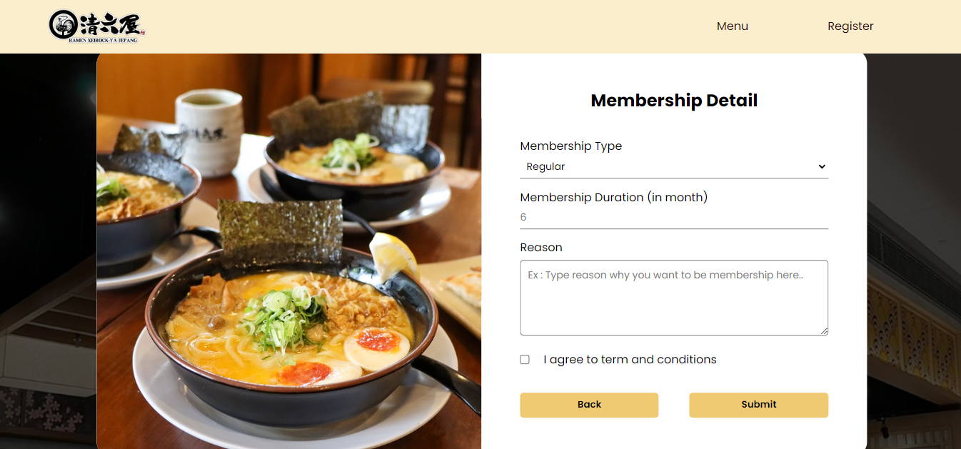

Figure 22. Membership detail form

* This part also contains **two** buttons: the **back** button and the **submit** button.
* If the **buttons** are **hovered**, **change** the **style** of the **button**.

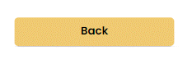

Figure 23. Back button



Figure 24. Back button (hover)

* If the user clicks the **back** button, **show** the **personal** **information** part and **hide** the **membership** **detail** part.
* If the user clicks the **submit** button, **redirect** the **user** to the **home** **page**.

Please run the EXE file to see the sample program.

## Komponen Penilaian

*Scoring Component*

|  |  |  |
| --- | --- | --- |
| No | Component | Weight |
| 1 | Component A | 50 |
| 2 | Component B | 50 |